**Multi-Depot Capacitated Green Vehicle Routing Problem (MDCGVRP)**

|  |  |
| --- | --- |
| **Frank Acquaye**  Faculty of Computer Science, HSE  fakvey@edu.hse.ru | **Elie Wanko**  Faculty of Computer Science, HSE  evankopokhdi@edu.hse.ru |

**Abstract**

In this project, we investigate a Multi-Depot Capacitated Green Vehicle Routing Problem (MDCGVRP). Our proposed solution is a variant of the Capacitated Green Vehicle Routing Problem (CGVRP), but here we are considering a situation where we have multiple depots. We then consider a situation in which distributors who are used to conventionally powered vehicles and want to gradually replace them with Alternative Fuel-powered vehicles (AFVs). They are faced with the daunting task of managing a fleet of both traditional fueled vehicles and alternatively fueled vehicles. AFVs start from the existing warehouses, serve customers and, at the end of the day, return to the original warehouses which serve as the only point of Alternative Fuel-powered Stations (AFSs) for recharge. The limited travel distance of AFVs before refueling forces them to function within a limited range especially if the distributor does not have the means of providing multiple refueling stations.

**Keywords:** vehicle routing problem; alternative fuel-powered vehicles; renewable energy; MDCGVRP, CVRP, VRP, TSP.

# Introduction

**Renewable** **energy** demand increased by about $1.5\%$ in Q1 2020, lifted by the additional output of new wind and solar projects that were completed over the past year. In most cases, renewables receive priority in the grid and are not asked to adjust their output to match demand, insulating them from the impacts of lower electricity demand. As a result, the share of renewables in the electricity generation mix rose considerably, with record-high hourly shares of variable renewables in Belgium, Italy, Germany, Hungary, and eastern parts of the US.

According to a recent International Energy Agency (IEA) study [1], 23% of global emissions are produced by the transport industry, with almost 75% of the emissions created by the road system. These statistics show a growing need to reduce the $CO_{2}$ emissions generated by the road sector. Green Logistics emphasizes the sustainability of logistics operations to reduce pollution in the road transport sector. Green logistics advocate the adoption of clean energy, such as electricity and hydrogen, to reduce pollution. The problem with the configuration of the green vehicle routing scheme is named the Green Vehicle Routing Problem (GVRP).

More and more distributors are faced with the daunting task of moving towards green energy in all aspects of operations. This often involves switching distribution vehicles to vehicles that consume alternate fuel. The challenge with alternate fuel however is the limited travel distance before the need for refueling. Hence these distributors often have vehicles that use traditional fuel and vehicles that use alternate fuel to be able to keep up with their main service offerings. Our goal is therefore to produce an optimization algorithm that maximizes the distribution paths of green fueled vehicles and minimizes the distribution paths of traditional vehicles all this while ensuring that the total demand for services/products is met.

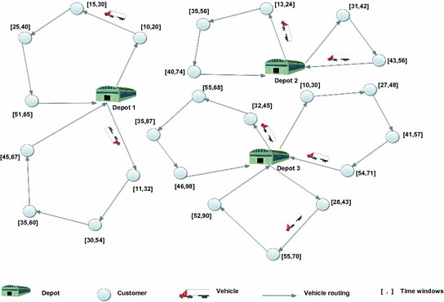

Typical schema of a MDCVRP

This paper is organized as follows. In Section 2, a related literature review is presented. Section 3 introduces the mathematical formulation and algorithm of our MDCGVRP. Section 4 presents the solution designed for solving MDCGVRP followed by the conclusion in Section 5.

# Literature Review

In recent years, MDCGVRP has received much attention from researchers and academics since people are becoming increasingly aware of environmental concerns**.** According to a comprehensive literature survey on the MDCGVRP in [2], there are three categories of MDCGVRP, namely Pollution Routing Problem (PRP), Green-VRP (G-VRP) and VRP in reverse logistics. Although these categories focus on economic costs and environment costs simultaneously, the PRP is focused on minimizing the fuel consumption, and the MDCGVRP is focused on using AFVs instead of conventional vehicles. Therefore, the objective function of PRP is the minimization of the total GHG (Greenhouse gas), and the objective of MDCGVRP is the minimization of the total travel distance of all AFVs.

# Problem Description and Formulation

A standard MDCGVRP can be described as finding routes with the least distance from a depot to a set of customers. Each customer is visited by the vehicle fleet only once, and the demand of the customer is satisfied after each visit. A vehicle starts from a depot, serves customers one-by-one, and, finally, returns to its originally assigned depot. During the service process, when the remaining fuel of a vehicle is not able to satisfy the demand of the next customer, the vehicle can return to the depot for refueling or recharging.

With our variant of the MDCGVRP, the distributor has a set of Green Vehicles and a set of Conventional Vehicles. The challenge however is the limited travel distance of Green Vehicles before needing to recharge. The objective of the problem is while maximizing the overall usage of AFVs, we are minimizing the total carbon emissions of operating all vehicles. Although in conventional literature

## Mathematical Formulation

|  |
| --- |
| $D$***=*** *set of depots, with $D=\{1, 2,…, d\}$ $d$*  ***=*** *the number of depots $N$*  *= set of clients, with $N=\{1,2,...,n\}$ $n$*  ***=*** *the number of clients $V$*  *= set of vetices (or nodes), with $V=\{0\}∪N$, where is the depot $A$*  *= set of arcs, with $A=\{(i,j)∈V^{2}:i≠j\}$ $c_{ij}$*  *= cost of travel over arc $(i,j)∈A$ $Q$*  *= the vehicle capacity $q_{i}$*  *= the amount that must be delivered to customer $i∈N$ $GVs$*  *= set of Green Vehicles, with $GVs=\{1,2,...,g\}$ $CVs$*  *= set of Conventional Vehicles, with $CVs=\{1,2,...,c\}$* |

The mathematical formulation for MDCGVRP can be presented as follows:

|  |  |  |
| --- | --- | --- |
| $$\min{\sum_{i,j∈A}{c_{ij}x_{ij}}}$$ | subject to | $$\sum_{j∈V,j≠i}{x_{ij}=1,i∈N}$$ $$\sum_{j∈V,j≠i}{x_{ij}=1,i∈N}$$ $$if x_{ij}=1→u_{i}+q_{i}=u_{j}, i,j∈A:j≠0,i≠0$$ $$q_{i}≤u_{i}≤Q, i∈N$$ $$x_{ij}∈\left\{0,1\right\}, i,j∈A$$ |

## Solution of MDCGVRP

In this section, we proposed a method designed to solve MDCGVRP. The task here is to decide whether for given set 𝑁 of customers, it can be partitioned into two or more subsets $N_{1} , N_{2} , …, N_{n}$ such that a given client is as close as possible to a depot. This is done by taking the minimum of the respective the Euclidean distances of customers from the depots. This methodology is better known as the Partition-Based Algorithm (PBA).

**Step 1:** Assign all customers to their nearest depot.

In case the distance between the customer and all depots are the same for all depots pick the depot with least customers,

In case all depots have the same number of customers randomly assign a customer to a depot

**Step 2:** Generate a GVRP route for each depot and associated customers as follows.

* **Step 2.1:** Generate GVRP routes based on nearest neighbour criteria (NNC).
  + Define a threshold distance which is equal to (maximum travel distance of the green vehicle)/2
  + Compute the euclidean distance for all arcs and sort in ascending order
  + From each node naively select the minimum arc, starting from the depot (node 0)
  + Continue with *step 3*  as long as the total distance covered is less than the threshold
  + All nodes accumulated in step 3 are removed from the main graph thereby creating two graphs. One for GVP and another for CVP
* **Step 2.2:** Solve each graph a CVRP

.

# Results of Our Approach

Random Data was generated for the initial setup our problem. For simplicity, we consider a case where we have 2 depots and 25 customers as shown on the map below. The green dot depicts the depot and the blue dots depict the customers.

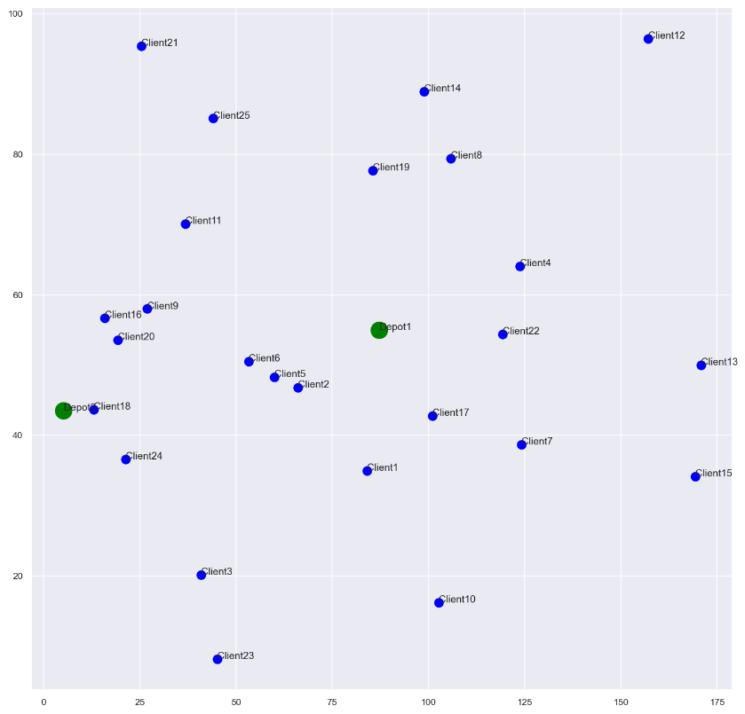

Figure 2: Location of depot and customers (green dot depicts the depot and blue dot depicts customers)

After running our PBA algorithm, we were able to assign every client to a depot.

Depot ID 0 delivers to 16 clients [0, 1, 3, 4, 5, 6, 7, 9, 11, 12, 13, 14, 16, 18, 21, 24]

Depot ID 1 delivers to 9 clients [2, 8, 10, 15, 17, 19, 20, 22, 23]

with the following relative distances

Depot 1 | Number of Clients - 16

{(0, 0): 20.226549139038344, (0, 1): 22.662684199306916,

(0, 3): 37.761750657494936, (0, 4): 28.069416026405914,

(0, 5): 34.12394937776985, (0, 6): 40.44746111176781,

(0, 7): 30.69680550145515, (0, 9): 41.72857517384714,

(0, 11): 81.25804460091169, (0, 12): 83.7434151839905,

(0, 13): 35.926546019559204, (0, 14): 84.70796837860917,

(0, 16): 18.464926558262082, (0, 18): 22.744235625980266,

(0, 21): 32.154707707336705, (0, 24): 52.61185035788426}

Depot 2 | Number of Clients - 9

{(1, 2): 42.699650485816655, (1, 8): 26.10657716350847,

(1, 10): 41.34723072958878, (1, 15): 17.005881051046867,

(1, 17): 7.873343939745037, (1, 19): 17.319503772572116,

(1, 20): 55.65538652980665, (1, 22): 53.37667142791655,

(1, 23): 17.6110323015215}

For every depot, we now apply a GVRP problem to come up with two separate routes, one for CVone for **GV.**

|  |  |
| --- | --- |
|  |  |
| Routes for CVs | **Routes for AFVs** |

# Conclusion

Recently, multi-national transportation companies have been focusing more on environmental sustainability performance. In this paper, the Multi-Depot Green Vehicle Routing Problem (MDCGVRP) is addressed. Conventional Vehicles (CVs) and Alternative Fuel-powered Vehicles (AFVs) are used to deliver goods to customers, with priority given to AFVs. Vehicles depart from different depots, serve customers, and, at the end, return to their original depots. In the service process, AFVs need to consider the remaining fuel level and the remaining cargo level, since AFSs are limited. We provide mathematical formulation to model the MDCGVRP problem with the aim of minimizing the total carbon emissions of fleet operation.

We proposed a simple algorithm based on the Partition-Based Algorithm (PBA) to solve MDCGVRP. We generated sample set of 25 customers and 2 depots. The experimental results reveal that the PBA can solve each instance within constraints, but the solution quality is somewhat unsatisfactory.

**Code Implementation:**

<https://github.com/acquayefrank/aql_project>

**References**:

1. Erdo˘gan, S.; Miller-Hooks, E. A green vehicle routing problem. Transp. Res. Part E Logist. Transp. Rev. **2012**, 48, 100–114. [CrossRef]
2. Lin, C.; Choy, K.L.; Ho, G.T.; Chung, S.H.; Lam, H. Survey of green vehicle routing problem: Past and future trends. Expert Syst. Appl. **2014**, 41, 1118–1138. [CrossRef]
3. First quarter of 2020 - compared with first quarter of 2019 [CrossRef]
4. Kaabachi, I.; Jriji, D.; Krichen, S. An improved ant colony optimization for green multi-depot vehicle routing problem with time windows. In Proceedings of the 2017 18th IEEE/ACIS International Conference on Software Engineering, Artificial Intelligence, Networking and Parallel/Distributed Computing (SNPD) IEEE, Kanazawa, Japan, 26–28 June 2017; pp. 339–344.
5. Jabir, E.; Panicker, V.V.; Sridharan, R. Design and development of a hybrid ant colony-variable neighbourhood search algorithm for a multi-depot green vehicle routing problem. Transp. Res. Part D Transp. Environ. **2017**, 57, 422–457. [CrossRef]
6. Li, J.;Wang, R.; Li, T.; Lu, Z.; Pardalos, P.M. Benefit analysis of shared depot resources for multi-depot vehicle routing problem with fuel consumption. Transp. Res. Part D Transp. Environ. **2018**, 59, 417–432. [CrossRef]
7. Wang, Y.; Assogba, K.; Fan, J.; Xu, M.; Liu, Y.;Wang, H. Multi-depot green vehicle routing problem with shared transportation resource: Integration of time-dependent speed and piecewise penalty cost. J. Clean. Prod. **2019**, 232, 12–29. [CrossRef]
8. Zhang, S., Gajpal, Y. & Appadoo, S.S. A meta-heuristic for capacitated green vehicle routing problem. *Ann Oper Res* **269,**753–771 (2018). [[CrossRef](https://doi.org/10.1007/s10479-017-2567-3)]